HBF – World Mental Health Day Social Media Toolkit

10 October 2022
Thank you for taking part in HBF’s social media toolkit for World Mental Health Day 2022. The messages and imagery below will help to raise awareness of mental health issues facing the construction industry and the support that is available to employees and their families.

Mental Health Awareness Week is a UK national initiative that inspires actions to promote good mental health for all. The social media toolkit has been designed to be used on media platforms Twitter and LinkedIn. If you have any questions, please email Maryam Baloch.

Day | Post type | Content | Imagery
One | Employer/ Industry focused | We are committed to making a difference. [Organization name] has signed the Building Mental Health charter to raise awareness and improve mental health in the home building industry. #WorldMentalHealthDay | 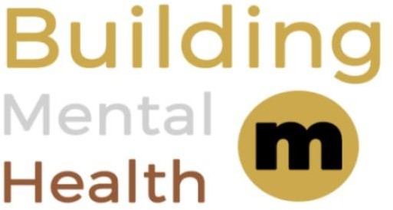

Two | Employer focused | It takes courage to talk about how you really feel. Over 55% of workers have experienced #mentalhealth issues in their life. Let's be part of the solution! See what action house builders are taking and find useful resources here www.hbf.co.uk/mentalhealth.  #WorldMentalHealthDay | 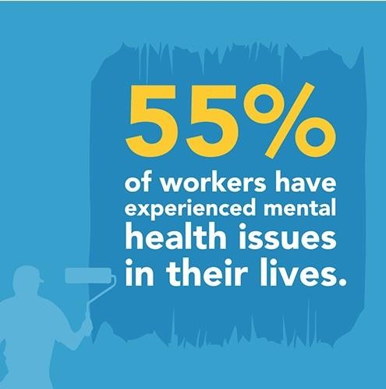
Three | Employee/ Public focused | Don't let it all build up, the Construction Industry Helpline is a free 24/7 confidential helpline for the construction industry’s workforce and their families. If you’re struggling, there is always help available. @LightHouseClub_ #WorldMentalHealthDay | 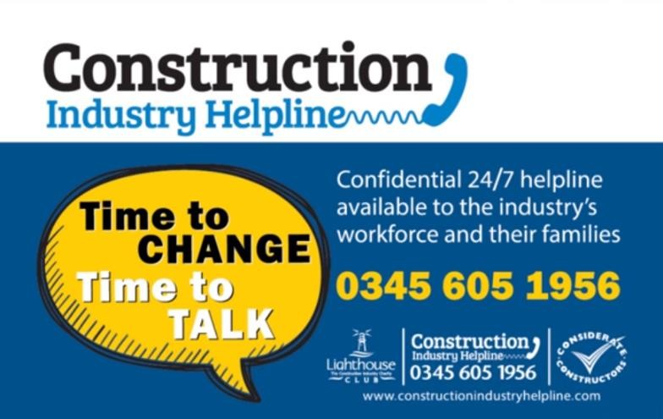

Four | Employer focused | 55% of workers have experienced a #mentalhealth problem. The Building Mental Health framework gives home builders 5 clear steps they can take to raise mental health awareness and address issues in the workplace-find tips and resources here https://hbf.co.uk/mentalhealth. @lighthouseClub_ #WorldMentalHealthDay | 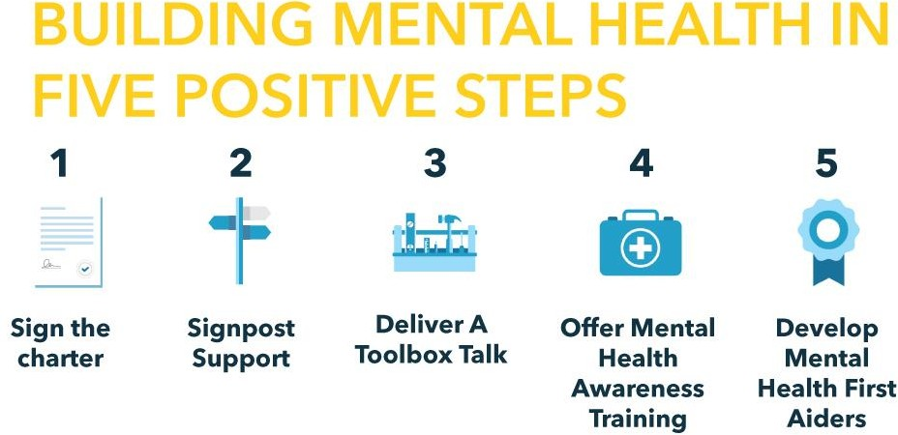
Five | Employer focused | Break down the stigma of mental health by starting a conversation. Toolbox Talks are a great way to raise awareness. For a home builder template you can adapt today, visit https://www.hbf.co.uk/policy/mental-health-awareness-home-building/mental-health-awareness-resources/  #WorldMentalHealthDay | 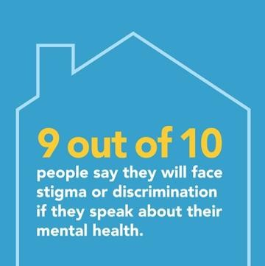
Six | Employee/ Public focused | Not everyone is comfortable talking about their feelings. The free Lighthouse Club app can help provide information and guidance on a range of issues. Download it on the App Store and Google Play now. #MentalHealthWeek | 